**PROJECT TITLE**

**24BCT13 – USER INTERFACE TECHNOLOGY MINI PROJECT REPORT**

**Submitted by**

Kesavarshini R

**(REG. NO: 23BSR040)**

#### Lakshna Sri

**(REG. NO: 23BSR026)**

Priyadharshini P P

**(REG.NO: 23BSR040)**

***In partial fulfilment of the requirements***

***For the award of the degree of***

**BACHELOR OF SCIENCE IN SOFTWARE SYSTEMS**

**DEPARTMENT OF COMPUTER TECHNOLOGY-UG**

**KONGU ENGINEERING COLLEGE**

**(Autonomous)**

#### PERUNDURAI, ERODE - 638 060



**NOVEMBER 2024**

**ABSTRACT**

**TABLE OF CONTENTS**

**CHAPTER No. TITLE PAGE No.**

**ABSTRACT 5**

**1 INTRODUCTION 11**

**2 REQUIREMENT ANALYSIS 12**

2.1 EXISTING SYSTEM 12

2.1.1 Drawbacks of Existing System 12

2.2. PROPOSED SYSTEM 13

2.2.1 Advantages of Proposed System 13

**3 SAMPLE CODING 15**

**4 SCREENSHOTS 27**

**5 CONCLUSION & FUTURE ENHANCEMENT 31**

5.1 CONCLUSION 31

5.2 FUTURE ENHANCEMENTS 31

**6 REFERENCES 50**

**CHAPTER 1**

# INTRODUCTION

An Online dress shopping platform allows users to browse and purchase various dresses available in the online store. The website displays comprehensive information about each dress, including price, model, size, and other relevant details. Users can browse products based on categories, and if they find a particular dress appealing, they can add it to their shopping cart. To proceed to checkout, users must first register on the site and then log in with valid credentials. Online shopping leverages the internet for electronic commerce, offering an attractive and detailed presentation of products.

Online shopping has become increasingly popular due to its convenience, allowing customers to shop from home and access a wide variety of products. Competitive pricing and easy navigation for product searches further enhance the online shopping experience. For sellers, online stores provide access to a global market, increasing customer reach and enhancing customer relationships. Additionally, web stores offer small-scale companies the opportunity to launch their products on a global scale.

The main objective of this project is to develop a web-oriented application that offers online shopping features for dresses. The home page will display all available shopping categories, and within each category, subcategories associated with specific items will be shown. Administrators have the authority to add new items to the list as needed, remove items at any time, and modify the prices of each item whenever necessary.

**CHAPTER-2**

# REQUIREMENT ANALYSIS

## 2.1 EXISTING SYSTEM

Offline Shopping are location-dependent, which means customers must physically visit the shop to place their order and for fittings. This can be inconvenient for those who live far from the shop or have busy schedules.

Customers typically need to make multiple visits for new arrivals and varieties which can be time-consuming.

Customers may not have access to the latest arrivals. Customers may not always be able to convey their preferences effectively, which can result in dissatisfaction with the finished garment.

### 2.1.1 DRAWBACKS OF EXISTING SYSTEM

The existing system has following disadvantages.

o It requires more effort to manage customer orders manually.

o Searching a customer order requires more time.

o Monitoring customer balance amount is very tough.

o Lack of designs.

## 

## 2.2 PROPOSED SYSTEM

Online Shopping offer customers the convenience of customizing the orders from the comfort of their home. This eliminates the need to visit the shop, saving time and effort.

Customers can efficiently track textile stock with real-time updates on product availability, categories, and pricing. Includes functionalities for adding, editing, and removing products.

Offers personalized shopping with customer accounts and provides admin tools for sales reports, customer behaviour analysis, and promotion management.

### 2.2.1 ADVANTAGES OF PROPOSED SYSTEM

o It makes easy to maintain records.

o Offers various variety options.

o Helps in gaining customers.

o Saves customer time.

**CHAPTER-3**

**SAMPLE CODING**

**Home.html**

**<**html>

<head>

<title>

</title>

</head>

<body>

…………..

</body>

</html>

**CHAPTER-4**

# SCREEN SHOTS

**Home Page:**

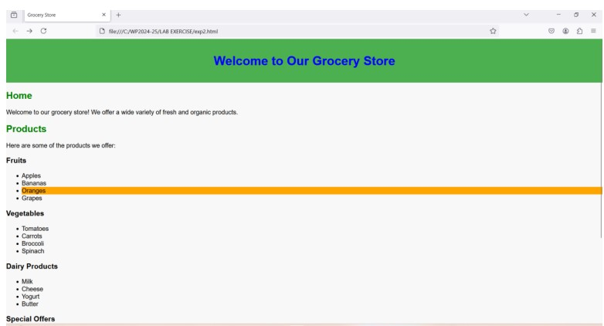

**CHAPTER 5**

**CONCLUSION AND FUTURE ENHANCEMENTS**

**5.1 CONCLUSION**

The project helps the administrator to maintain all orders and details. It reduces manual work. Since the application is designed as a website, any user can be using the website. The application is tested well and end-user satisfaction is found to be more. The application is designed such that minimum computer knowledge is required for the end user.

**5.2 SCOPE FOR FUTURE DEVELOPMENT**

The application becomes useful if the below enhancement is made in the future.

* + - The consolidated complaints details can be got from the customer.
    - Report generation will be enhanced.

The application

**CHAPTER 6**

**REFERENCES**

1.LINKS

2.BOOKS WITH AUTHOR NAME